
RAJALAKSHMI INSTITUTE OF TECHNOLOGY
(An Autonomous Institution, Affiliated to Anna University, Chennai)

DEPARTMENT OF CSE (ARTIFICIAL INTELLIGENCE AND MACHINE LEARNING)
ACADEMIC YEAR 2026 - 2027
SEMESTER IV
DATA ANALYTICS LABORATORY
MINI PROJECT REPORT

REGISTER NUMBER | 2117240030165
NAME | YASHWANTH.M.C.
PROJECT TITLE | Develop a global trade analytics system that studies trade patterns between countries.
DATE OF SUBMISSION
FACULTY IN-CHARGE | Mrs. BHAVANI M

Signature of HOD Signature of Faculty In-charge

INTRODUCTION
- Artificial Intelligence and Data Analytics play a significant role in extracting meaningful insights from large datasets. In today’s global economy, trade between countries is a key factor influencing economic growth and development.

- This project focuses on developing a Global Trade Analytics System to analyse trade patterns using data analytics techniques. The system helps in identifying trends, major trading partners, and key commodities involved in international trade.

- The importance of this project lies in its ability to provide data-driven insights that can support decision-making for governments, businesses, and researchers.
PROBLEM STATEMENT
- To develop a data analytics system that analyzes global trade data and identifies patterns in exports between countries based on year, commodity, and trade value.
GOAL
- To analyze export trade data between countries
- To identify top exporting countries
- To study year-wise trade trends
- To analyze commodity-wise export patterns
- To visualize trade data using graphs
THEORETICAL BACKGROUND
1. Data Analytics
Data analytics involves examining datasets to draw conclusions about the information they contain. It includes:
- Descriptive Analytics
- Diagnostic Analytics
- Predictive Analytics
2. Time Series Analysis
Time series analysis is used to study data collected over time. It helps in identifying:
- Trends
- Patterns
- Fluctuations

3. Data Visualization
Visualization techniques such as line graphs and bar charts help in understanding complex data easily.
4. Literature Survey
- Global trade analysis is widely used in economic forecasting
- Previous studies use machine learning and statistical methods
- Tools like Python, Pandas, and Matplotlib are commonly used
5. Justification for Choosing Method
- Python provides powerful libraries for data analysis
- Easy handling of large datasets
- Effective visualization tools
ALGORITHM EXPLANATION WITH EXAMPLE
Algorithm: Data Analysis using Pandas
Steps:
- Load dataset
- Clean data (remove null values)
- Group data by country/year/commodity
- Calculate total trade values
- Visualize results

Example
If we group data by country:
df.groupby("country")["value"].sum()

IMPLEMENTATION AND CODE:

import pandas as pd
import matplotlib.pyplot as plt
df = pd.read_csv("2010_2021_HS2_export.csv")
df.dropna(inplace=True)

top_countries = df.groupby("country")["value"].sum().sort_values(ascending=False)
yearly = df.groupby("year")["value"].sum()
yearly.plot()
plt.title("Year-wise Export Trend")
plt.xlabel("Year")
plt.ylabel("Export Value")
plt.show()
top_countries.head(10).plot(kind='bar')
plt.title("Top Exporting Countries")
plt.show()

OUTPUT
1. Year-wise Export Trend
- Shows increase in exports over time
- Peak observed in recent years
2. Top Exporting Countries
- USA is the highest importer
- Followed by UAE, China, and others
3. Commodity Analysis
- Mineral fuels and oils dominate exports
- Machinery and metals are also significant
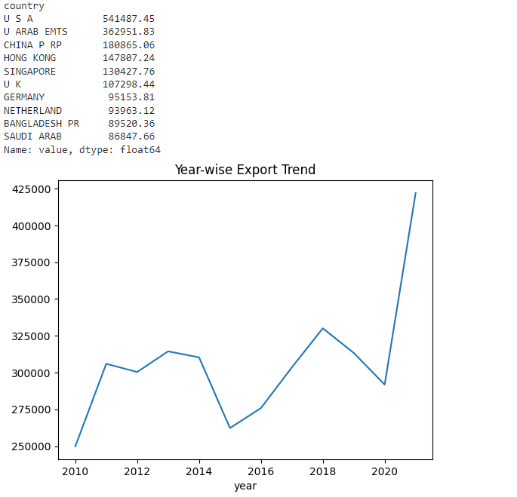
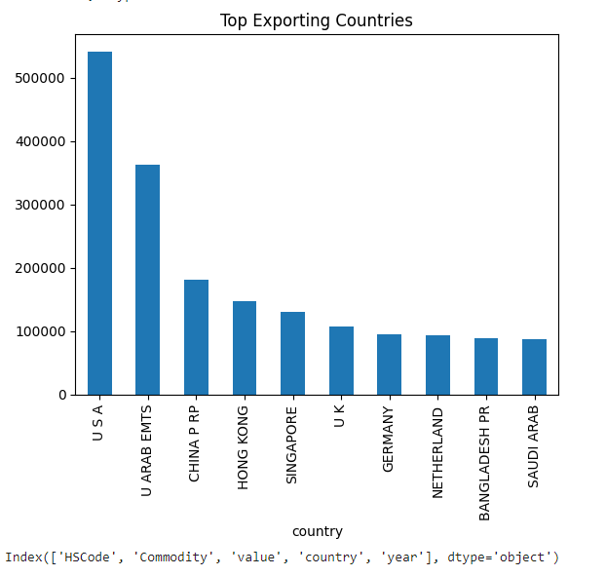
RESULTS AND FUTURE ENHANCEMENT
Results
- Identified major trade partners
- Observed increasing trade trend
- Found key export commodities
Future Enhancements
- Include import data for comparison
- Use machine learning for prediction
- Build dashboard using Power BI
- Real-time trade data analysis
Git Hub Link of the project and report
REFERENCES
- Kaggle – Global Trade Dataset
- World Bank Data – Trade Statistics
- Python Documentation – Pandas Library
- Matplotlib Official Documentation
- Research papers on Trade Analytics

